USER INTERFACE DESIGN Jai Shuriya
EXPERIMENT -5 2116240701200

Task Analysis:
Task Analysis is the process of breaking down a user's interactions with the StudySync application into smaller, manageable steps to understand how users achieve their goals such as managing notes, checking timetables, and organizing tasks. It helps in identifying user needs, usability issues, and areas for improvement.

Key Aspects of Task Analysis:
- Understanding what tasks users perform in the StudySync app.
- Identifying the sequence of actions required to complete each task.
- Analyzing user pain points and inefficiencies.
- Defining requirements to improve the overall user experience.

User Flow:
User Flow is a visual representation of how users navigate through the StudySync application to complete a specific goal. It shows the steps users take from entering the app to completing actions such as adding notes or managing tasks.

Key Aspects of User Flow:
- Represents decision-making paths (e.g., what happens if login fails?).
- Maps different navigation possibilities (e.g., switching between features).
- Shows how users move between screens like Login, Home, and Organizer.

User Flow for StudySync Application:
Start → Open App → Login/Register → Home Dashboard → Select Feature
→ Notes → Add/View Notes → Save Changes → Return to Home
→ Timetable → Add/View/Edit Schedule → Save Changes → Return to Home
→ Task Manager → Add/Complete Task → Update Task → Return to Home
→ Exit App → End

User Flow for StudySync Application

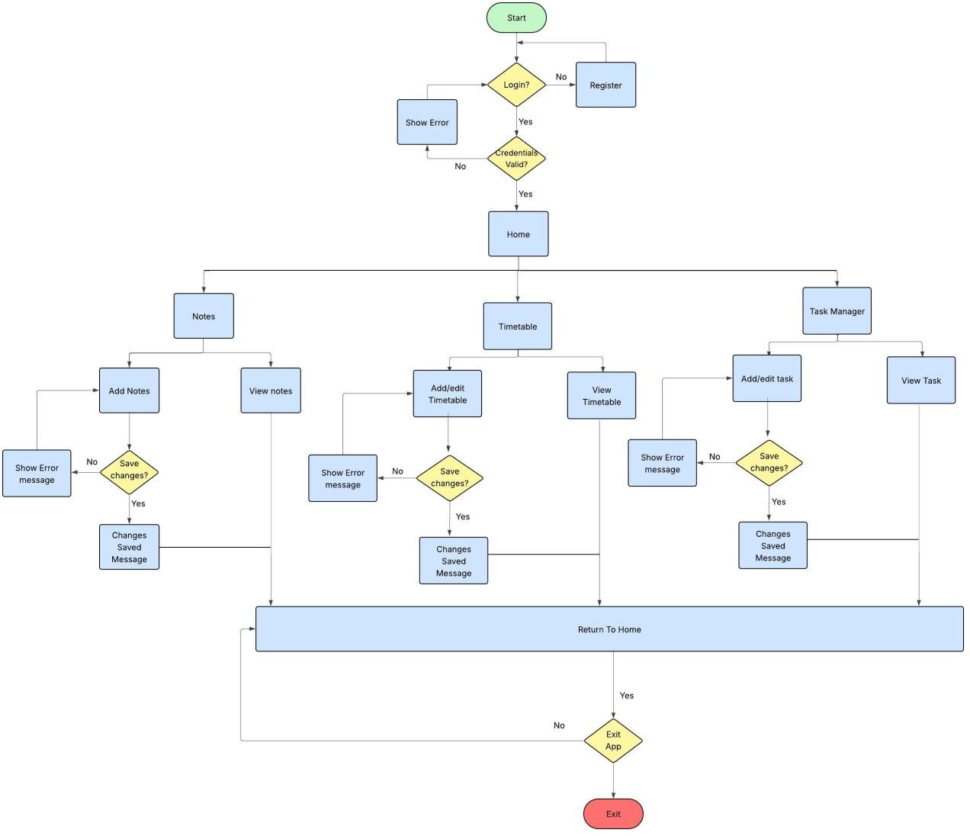

Step 1: Start
- The user opens the StudySync application.
- The login screen is displayed.

Step 2: Login or Register
- If the user already has an account, they enter their credentials and log in.
- If the user does not have an account, they register first and then log in.
- If login credentials are incorrect, an error message is shown and the user retries.

Step 3: Home Dashboard

- After successful login, the user enters the Home screen.
- The Home screen displays three main options:
  - Notes
  - Timetable
  - Task Manager

Step 4: Notes Management
- The user selects the Notes option.
- They can view previously saved notes.
- The user can click “Add Note” to create a new note.
- After entering the title and description, the user saves the note.
- The saved note appears in the notes list.
- The user can return to the Home screen.

Step 5: Timetable Management
- The user selects the Timetable option from the Home screen.
- The weekly schedule is displayed.
- The user can add or edit subjects and time slots.
- After making changes, the user saves the schedule.
- The updated timetable is displayed.
- The user can return to the Home screen.

Step 6: Task Manager
- The user selects the Task Manager option.
- A list of tasks is displayed.
- The user can add a new task by entering task details and due date.
- The user can mark tasks as completed.
- Completed tasks are visually distinguished (e.g., checkbox or strike-through).
- The user can return to the Home screen.

Step 7: Exit Application
- After completing tasks, the user can choose to exit the application.
- The process ends.

End of Process
  - The user has successfully managed notes, updated timetable, or completed tasks.
  - The application improves productivity and organization for students.

